**Center Name: ACE-HCMC-2-FPT.**

**Address: 391A Nam Ky Khoi Nghia, P.Vo Thi Sau, Q.3 , Viet Nam**

**BizWorks  
User’s Guide**

|  |  |  |
| --- | --- | --- |
| **Supervisor:** | Mr. Le Tuan Xuyen | |
| **Semester:** | 4 | |
| **Batch No:** | T1.2210.A1 | |
| **Group No:** | 3 | |
| **Order:** | **Full name** | **Roll No.** |
| 1. | Pham Phu Dien | Student1427807 |
| 2. | Nguyen Minh Tri | Student1424177 |
| 3. | Nguyen Xuan Duong | Student1427717 |
| 4. | Ho Quoc Trong | Student1331700 |

* **This is to certify that**

**Mr.** Pham Phu Dien

**Mr.** Nguyen Minh Tri

**Mr.**Nguyen Xuan Duong

**Ms.**Ho Quoc Trong

**have successfully designed & developed:**

eProject: BizWorks

* **Submitted by:**

Mr. Le Tuan Xuyen

**Date of issue:** 24/09/2024

**Authorized Signature:**

# Home page

`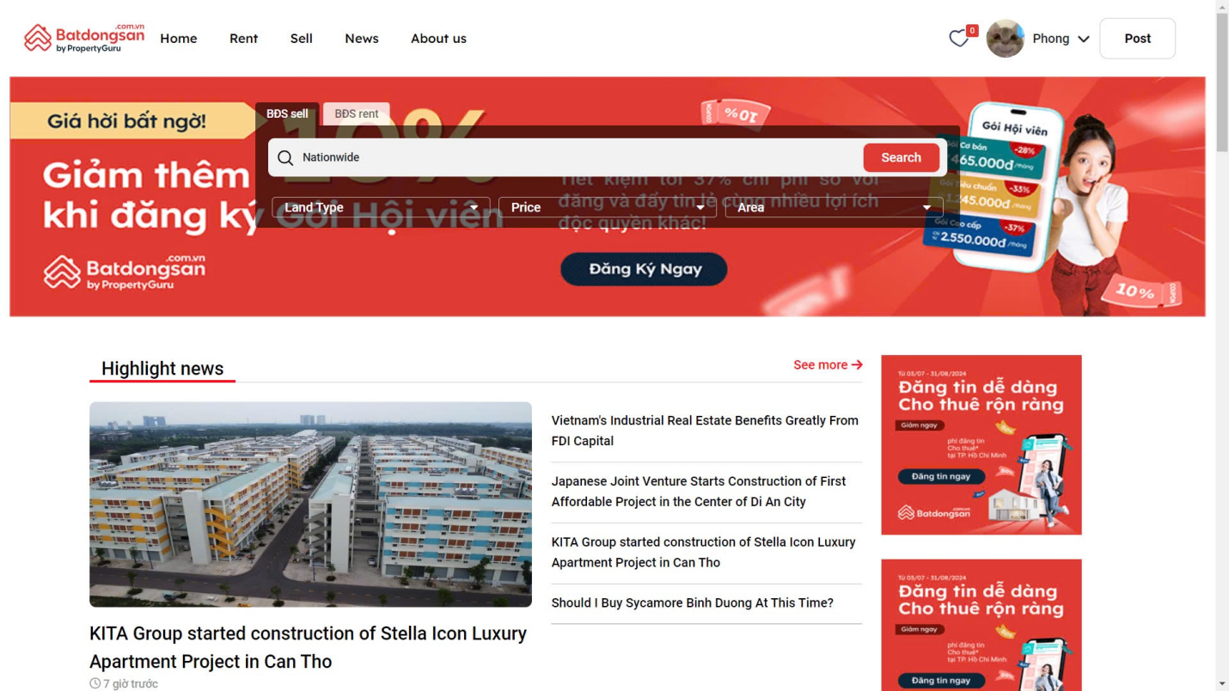

1. Login and ForgotPassword Pages

You can log in if Admin has created an account for you

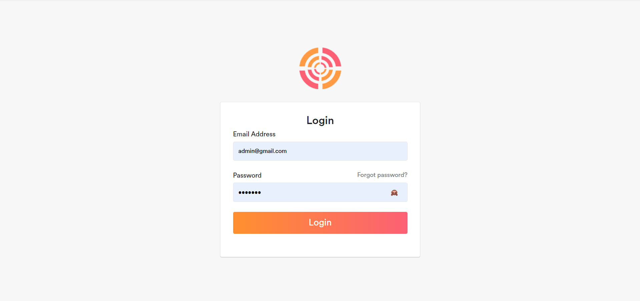

You can use forgot password to reset the password for your account in case you have forgotten your password

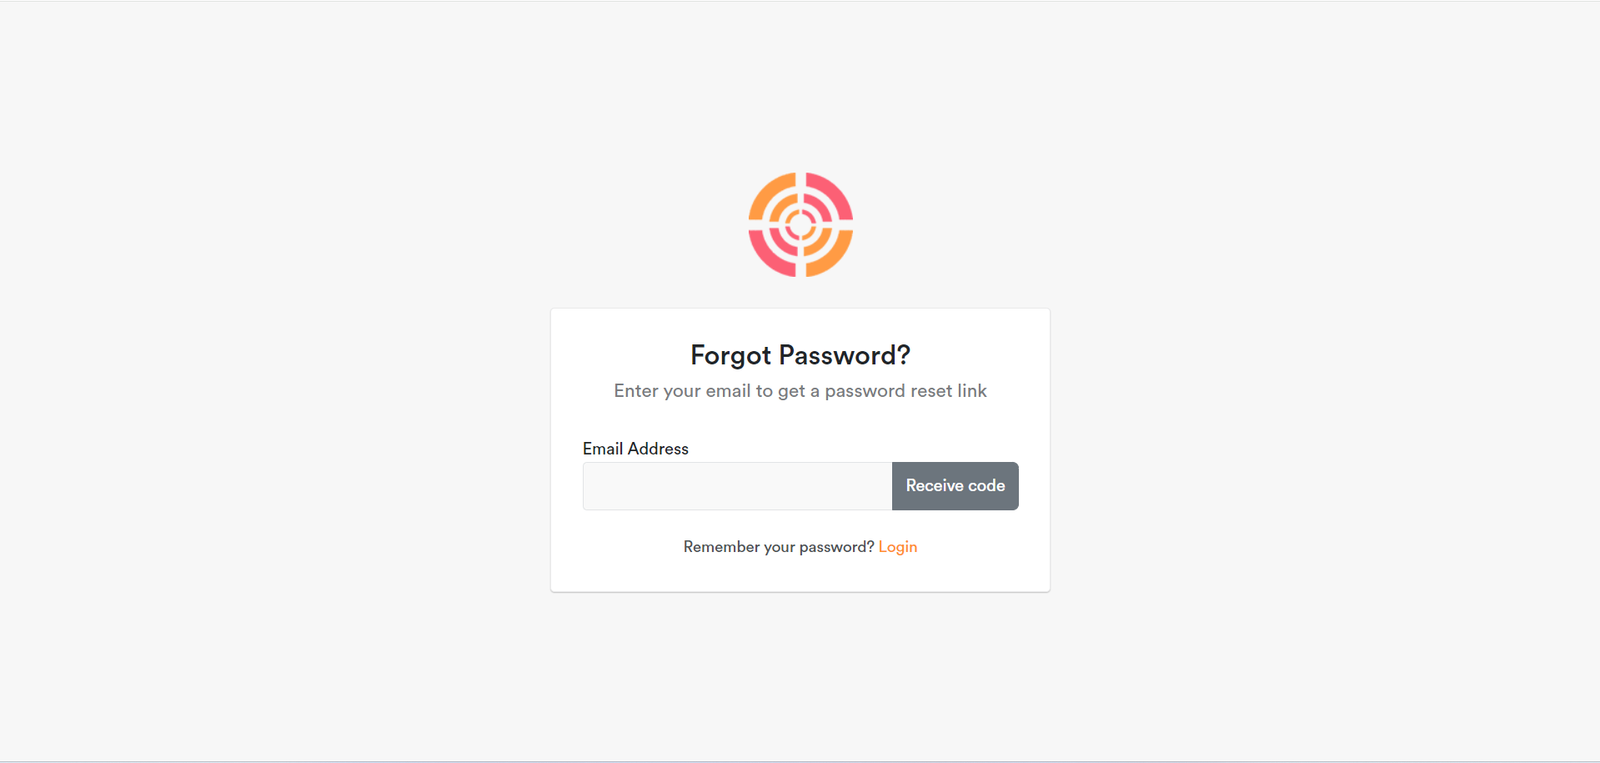

There will be a verification code sent to your gmail then you can change your new password

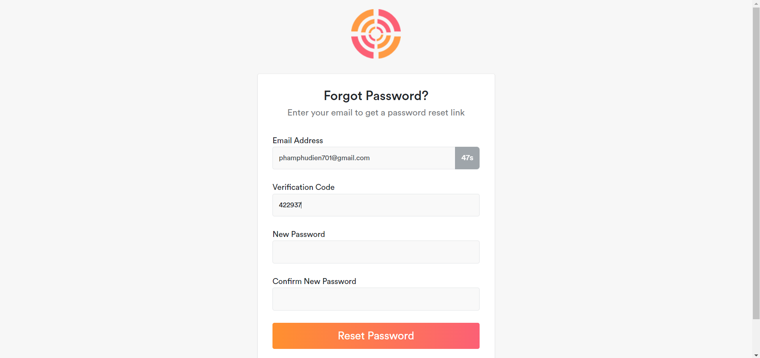

When you log in as an Admin, you will see the list of employees and functions for the Admin

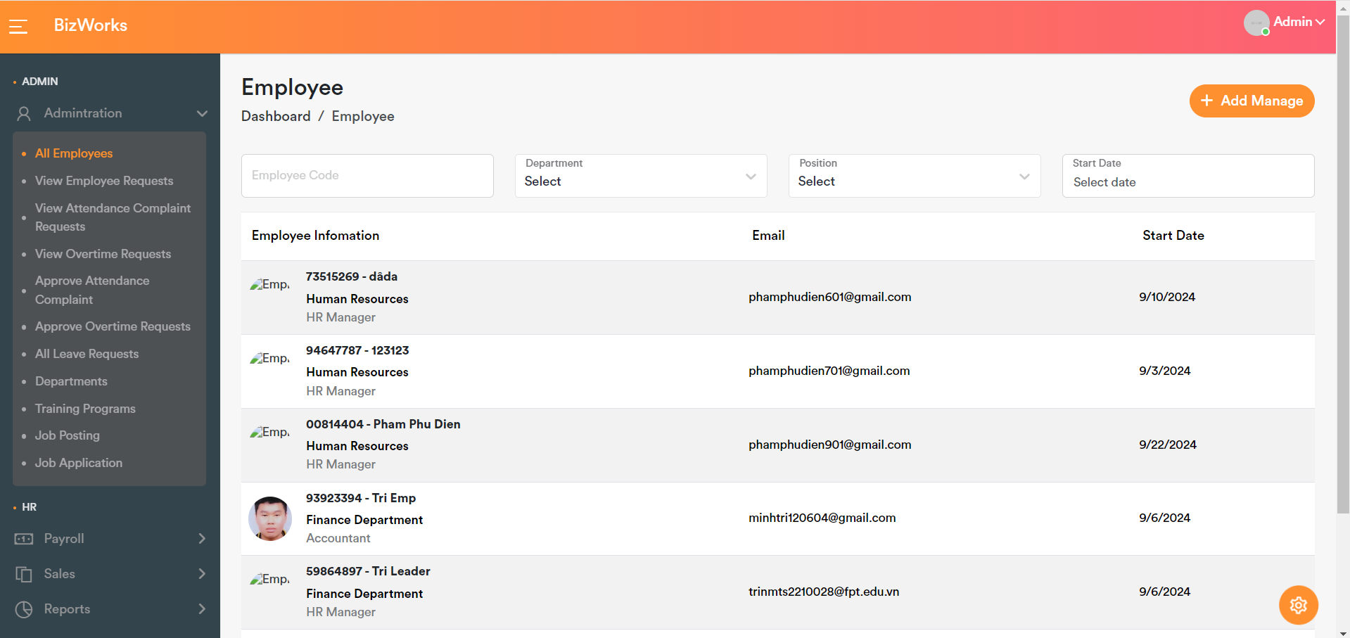

*IMG_256*

As an admin you can add employees with the role of Manager

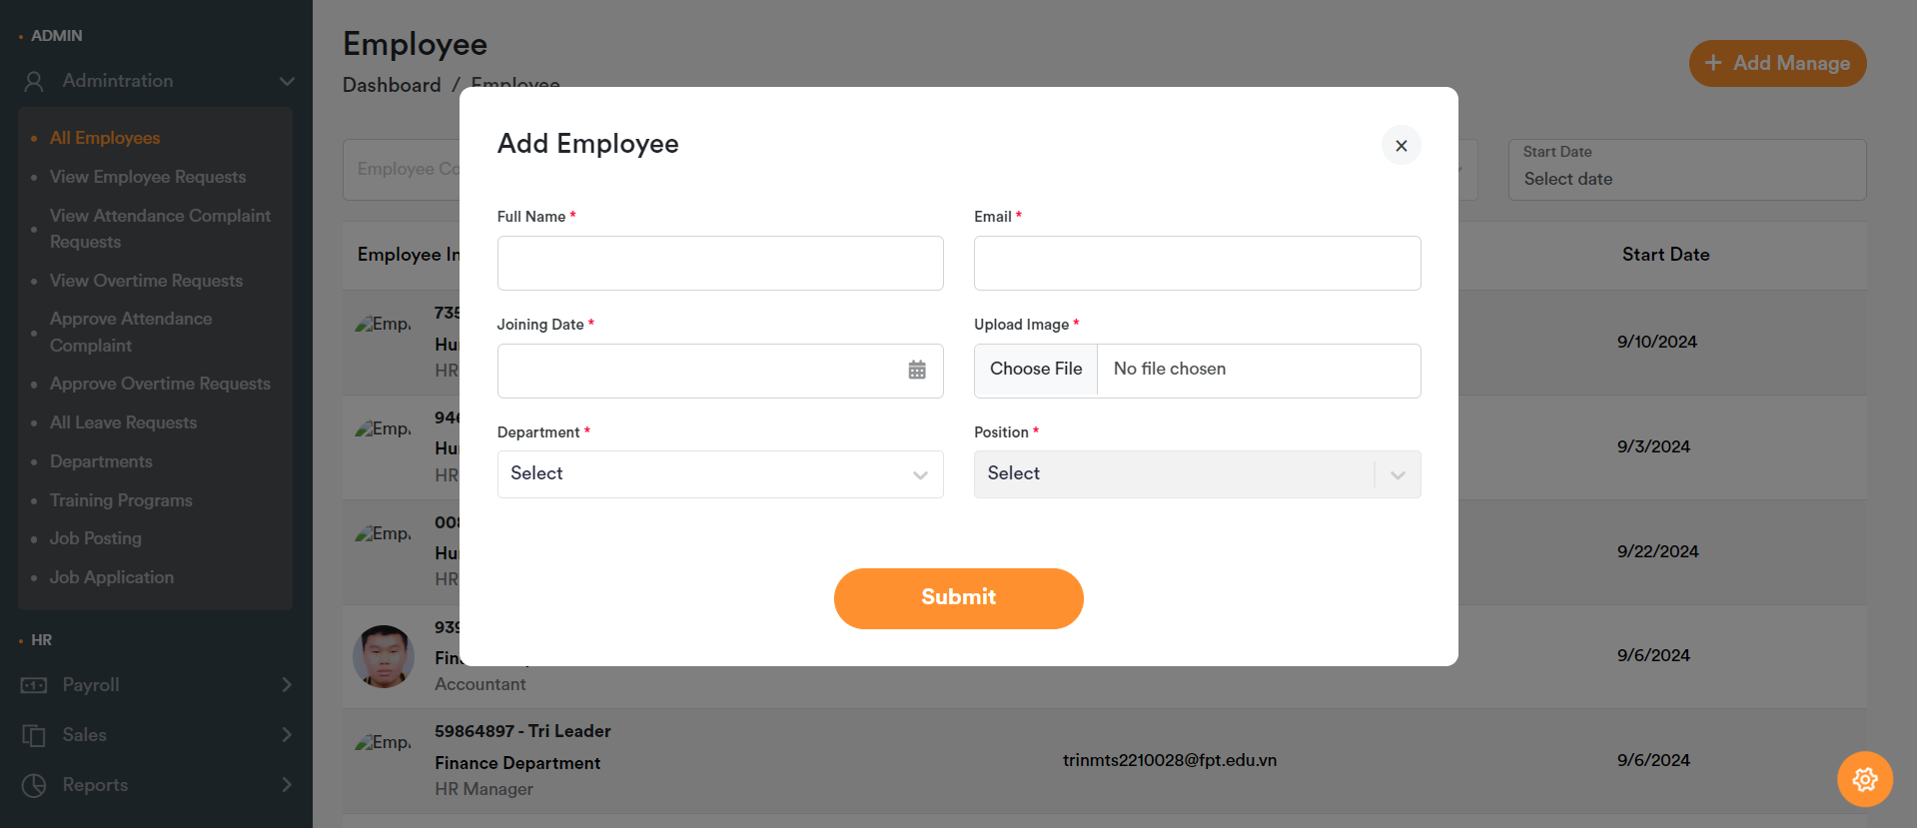

After the admin successfully creates an account, there will be a confirmation code with a temporary password for the newly created account for the management role.

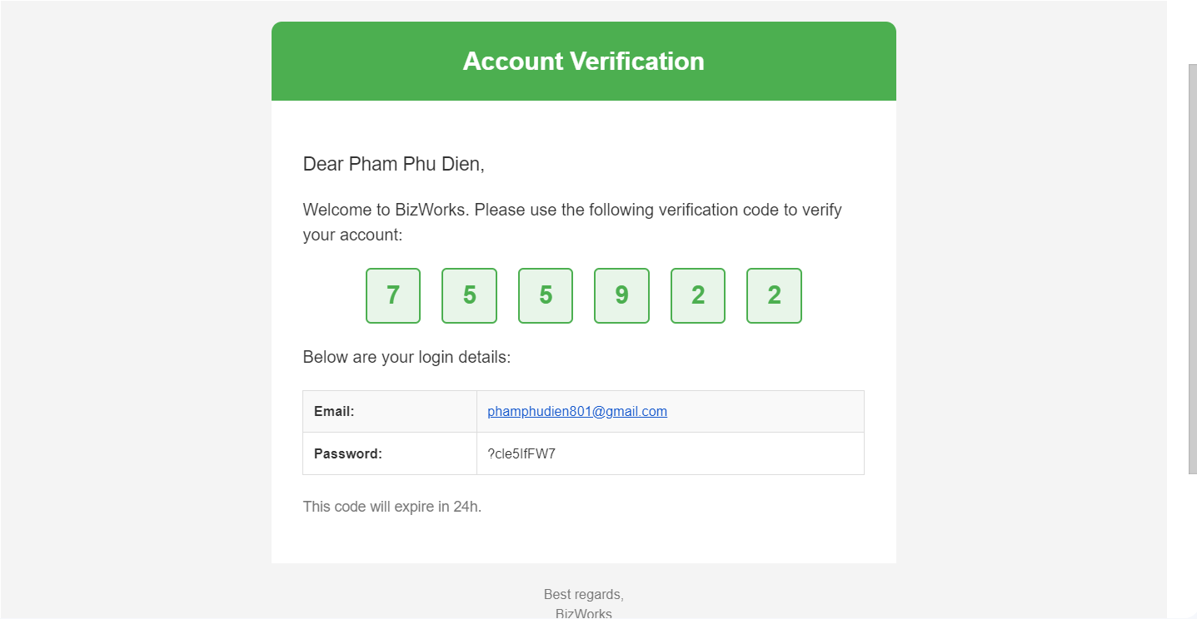

You will use a temporary password to log in

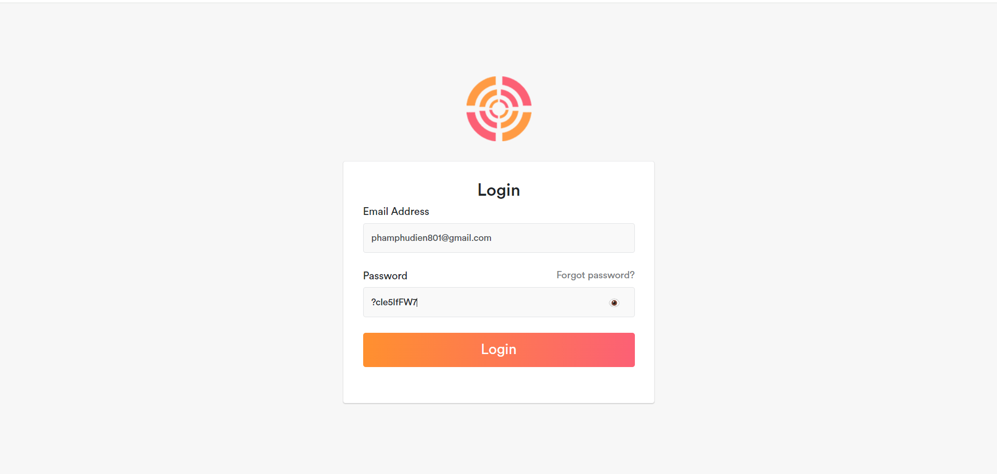

When you log in, you will be asked for the confirmation code previously sent to gmail along with the temporary password

*IMG_256*

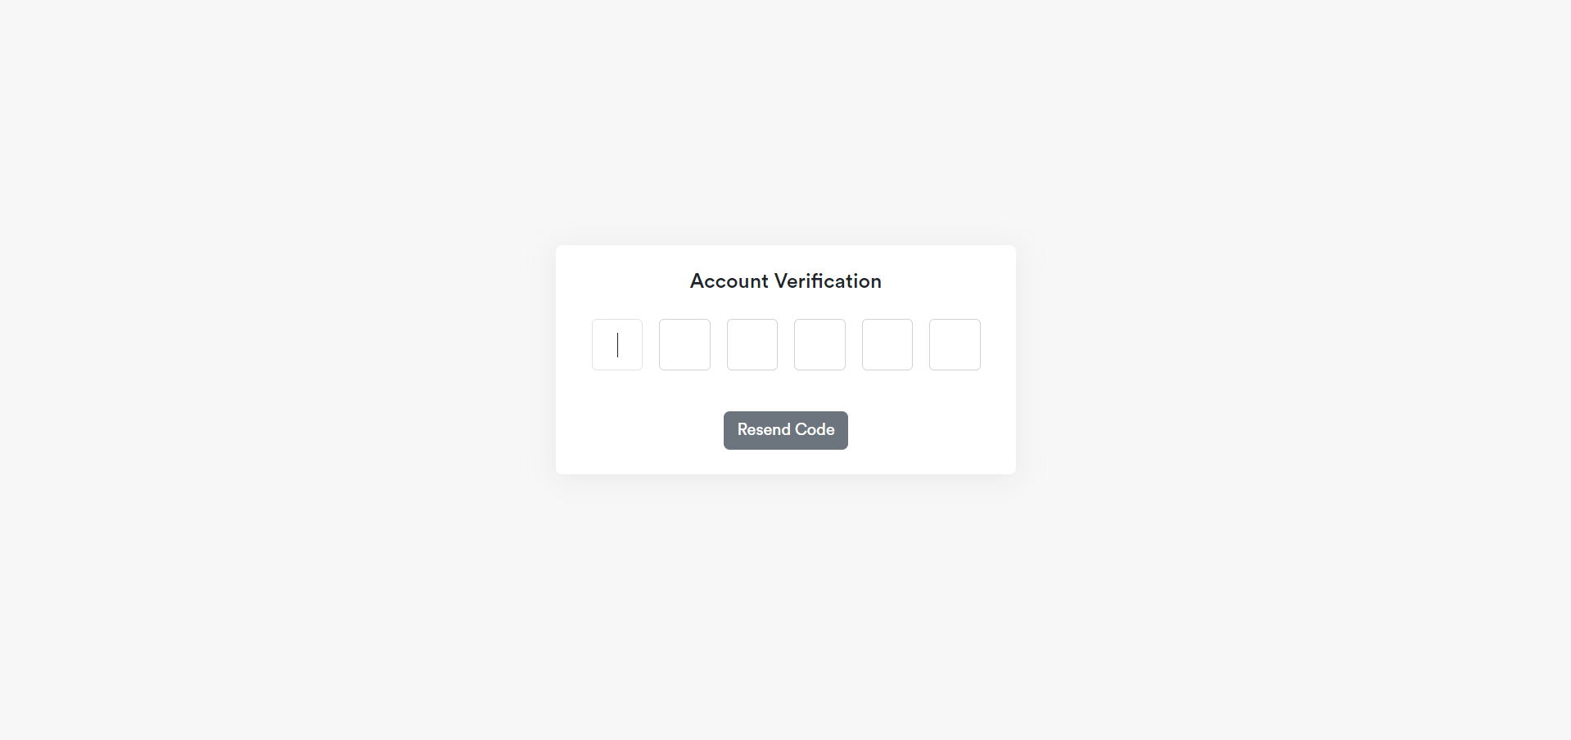

If you enter the correct code it will take you to your own password change page

*IMG_256*

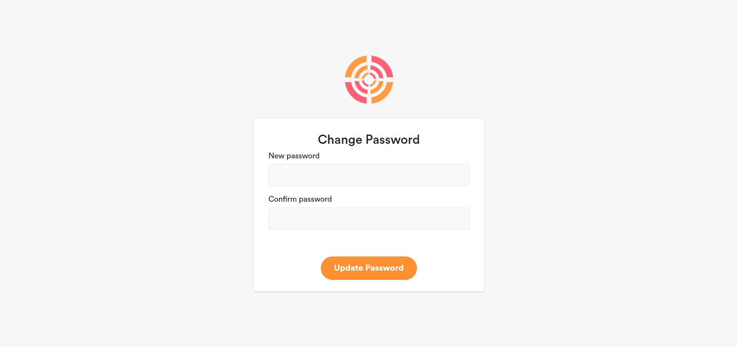

# User Profile Page

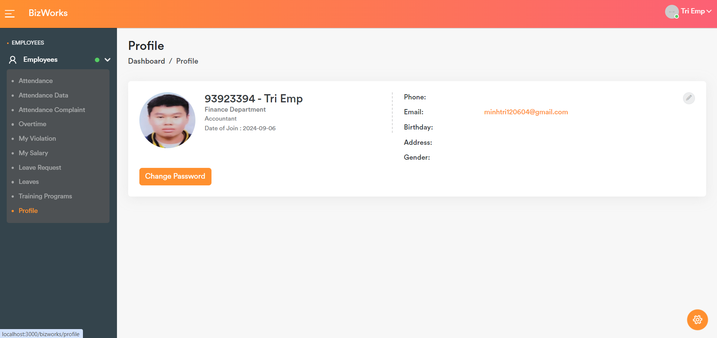

. 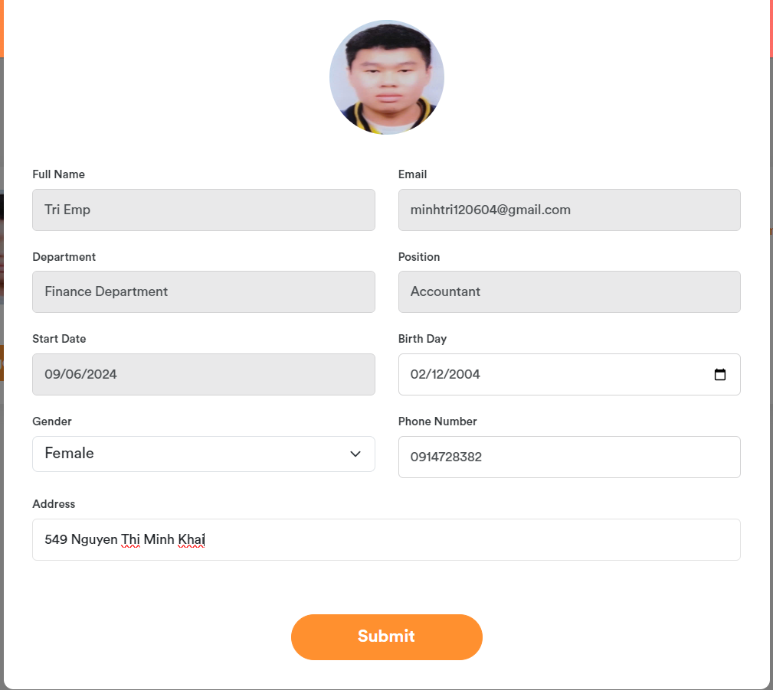

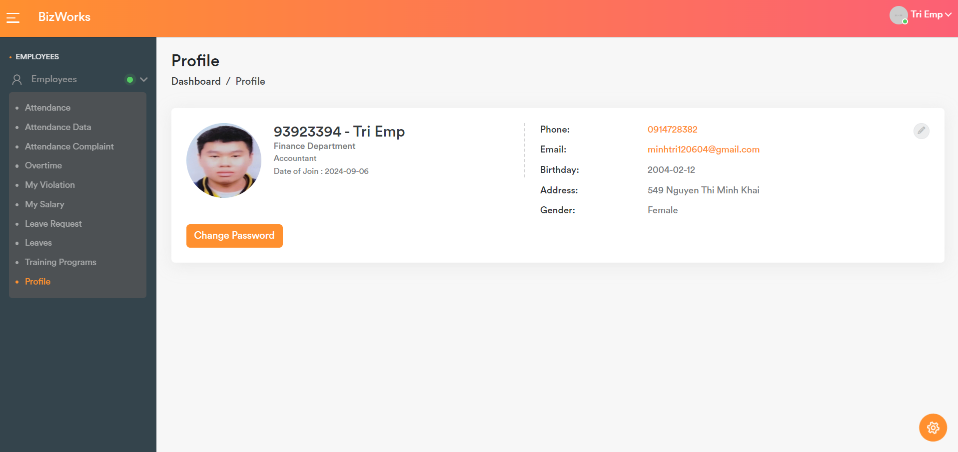

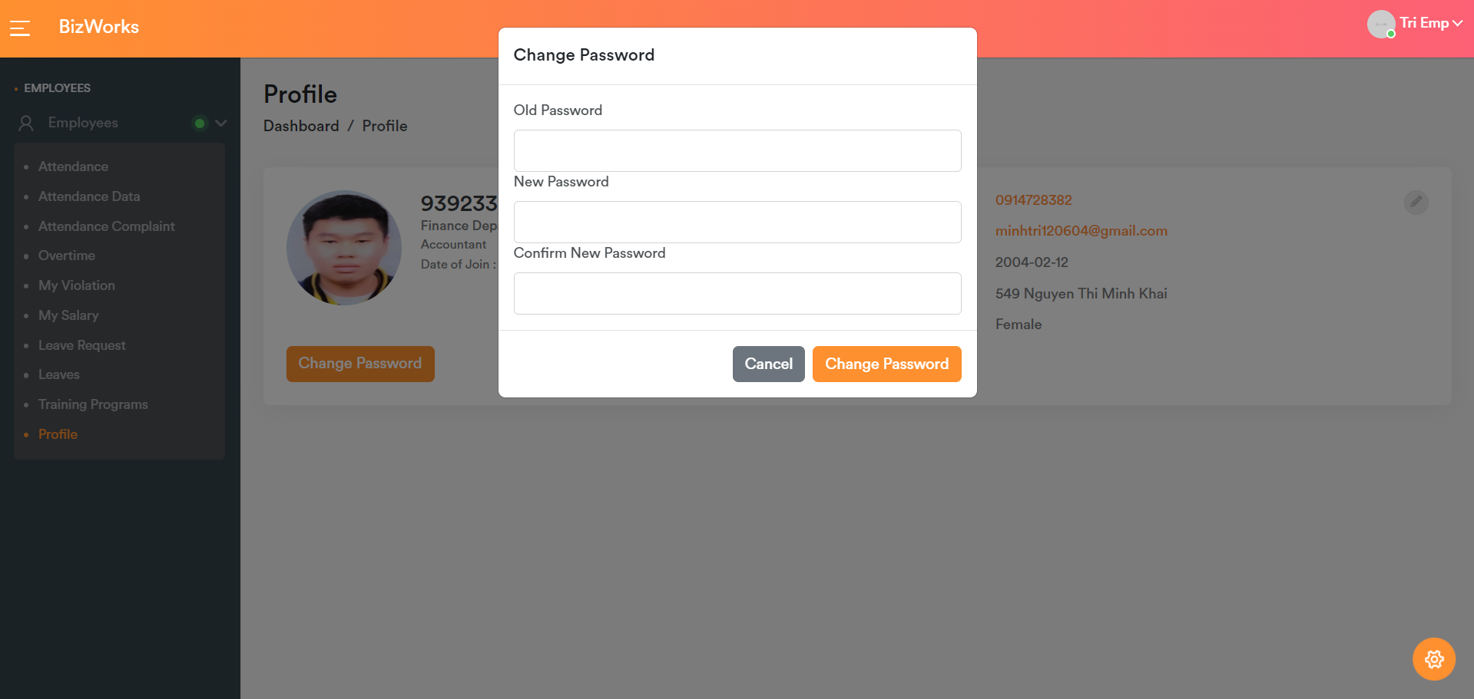

You can do timekeeping, the timekeeping section is only open at fixed times from 7:55 a.m. to 4:55 p.m. and has a lunch break from 12:00 p.m. to 1:00 p.m.

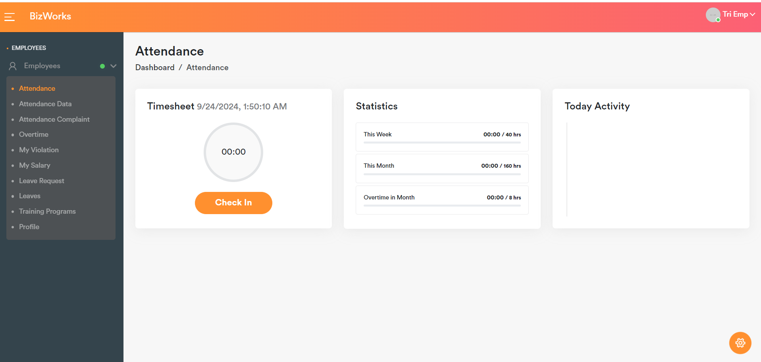

*IMG_256*

Timekeeping data page, complaints, overtime registration

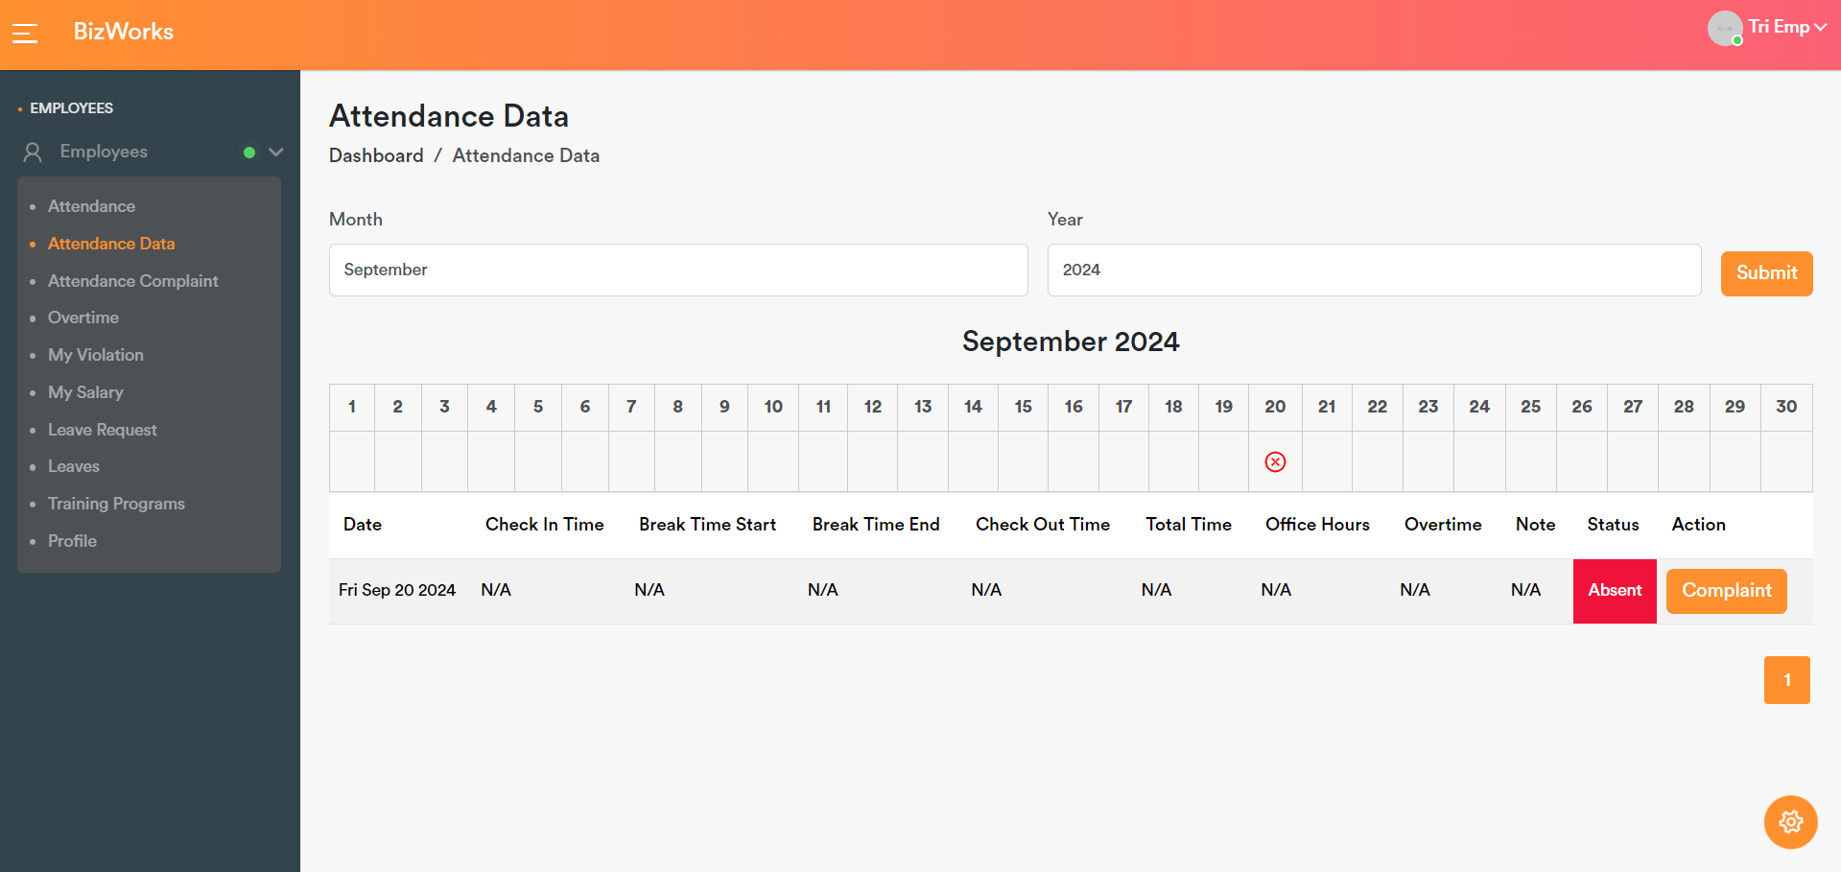

See timekeeping complaints

*IMG_256*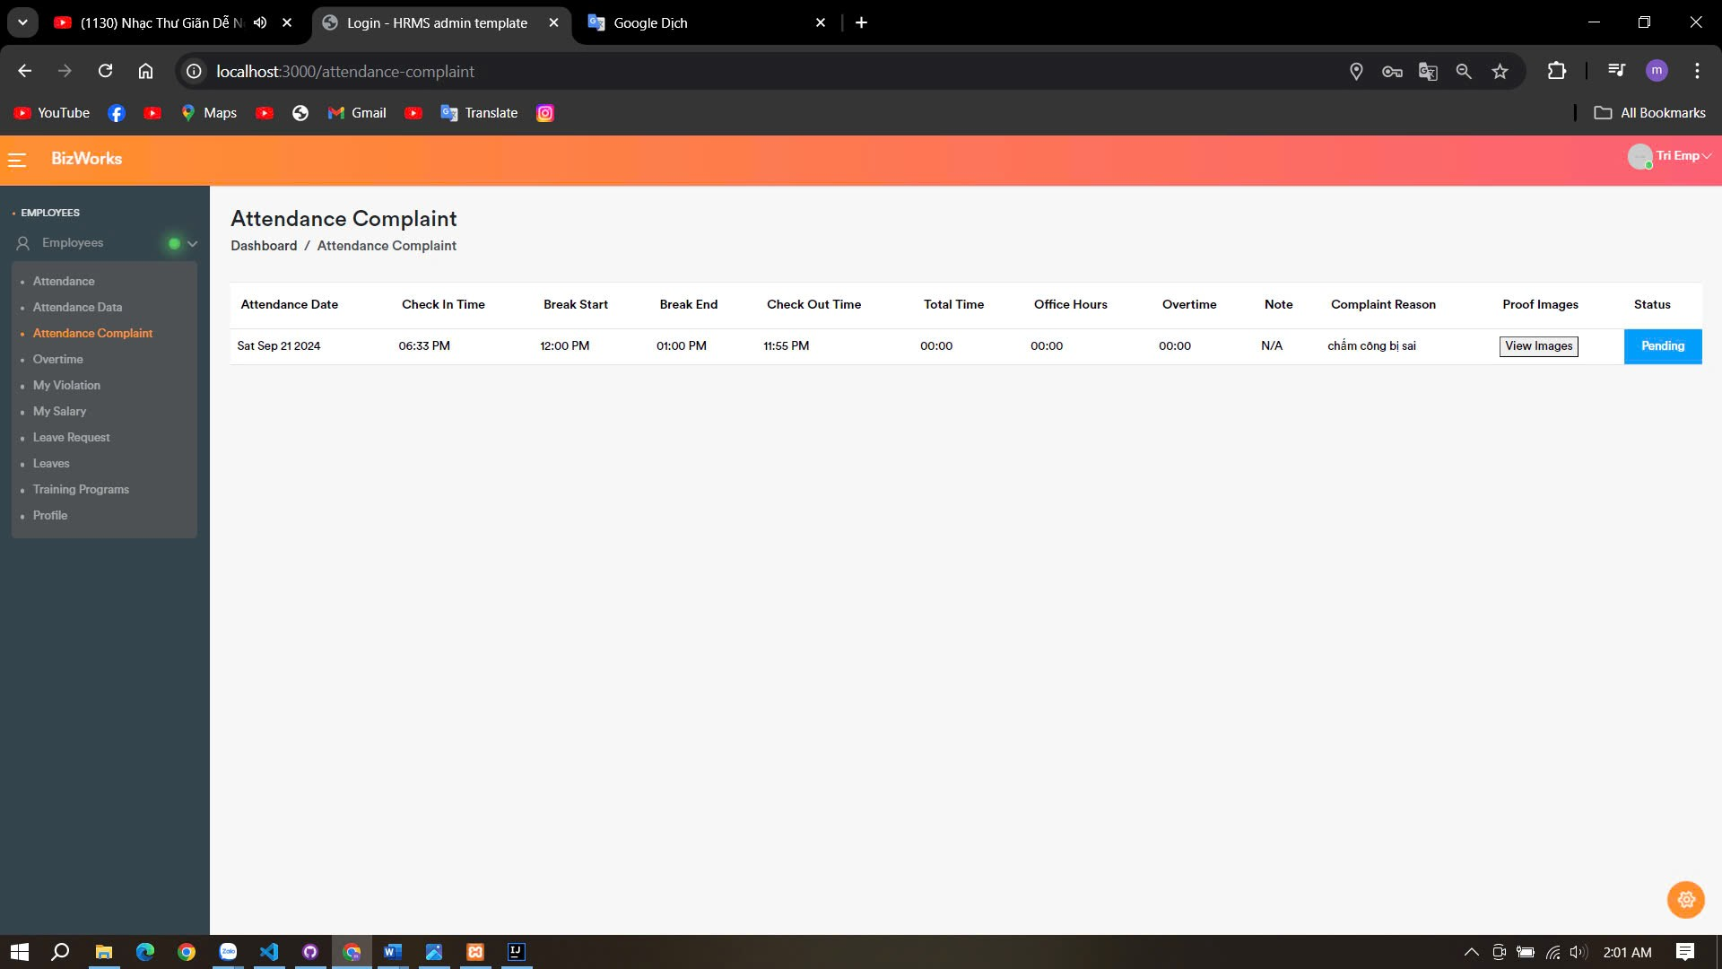

Overtime

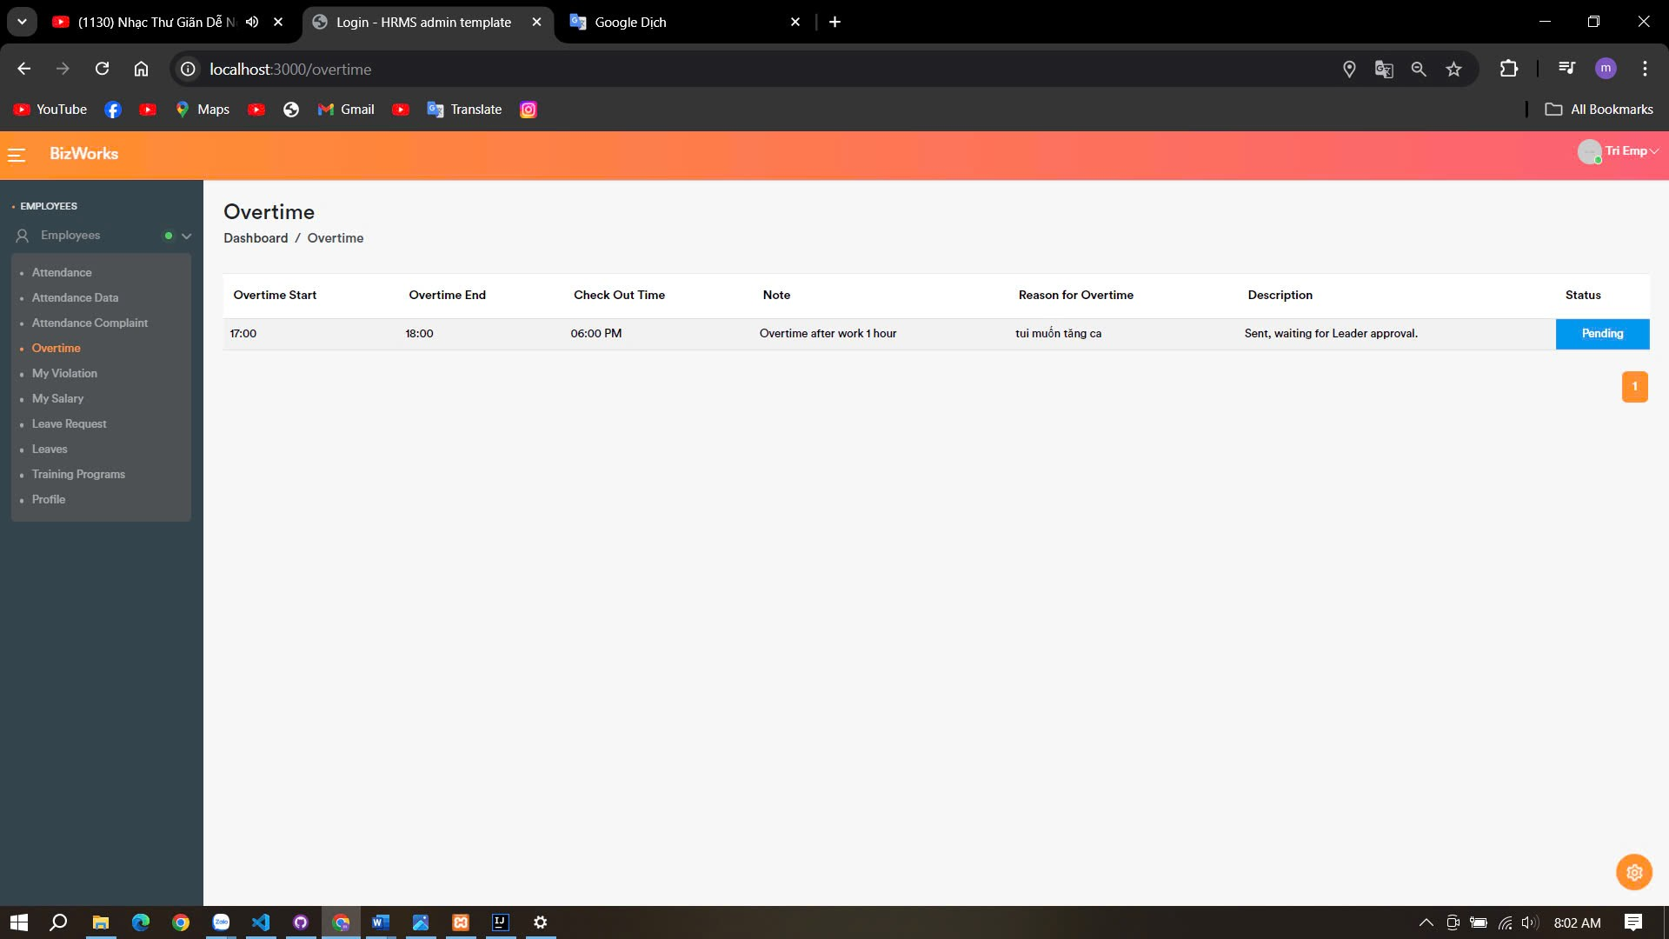

Leave Request History

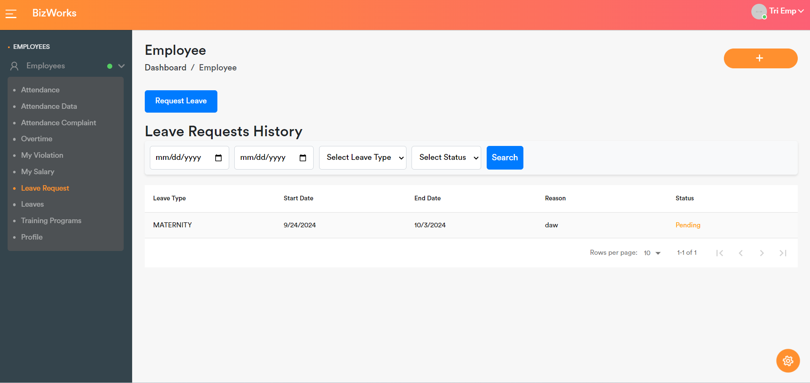

Admin Page

* Admin can view all the users.

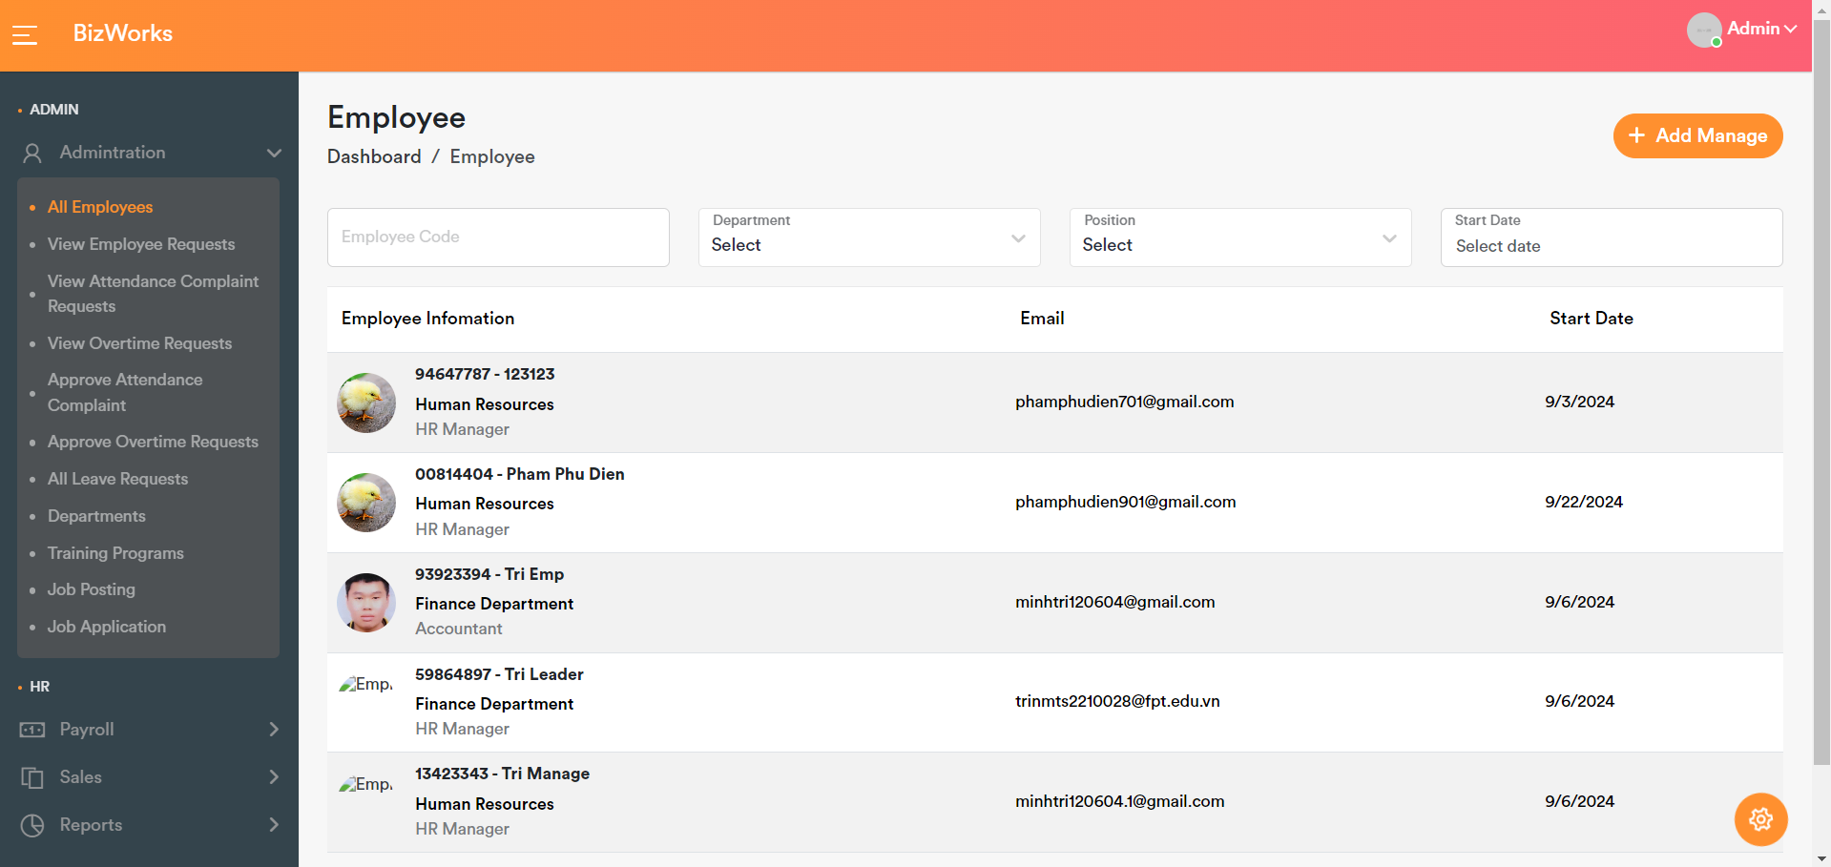

Admin can view all Departments.

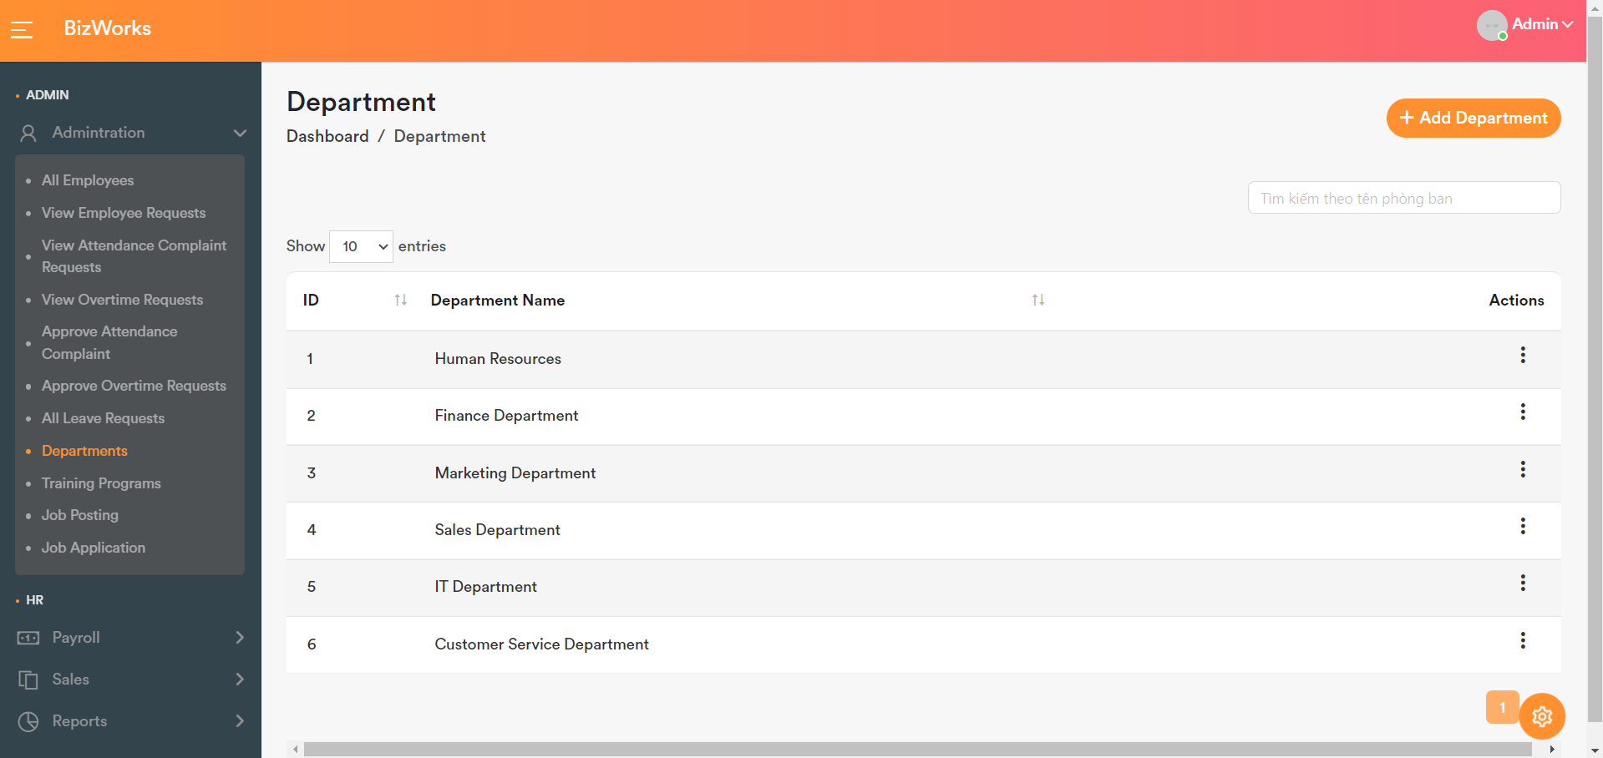

Missed Checkout Correction

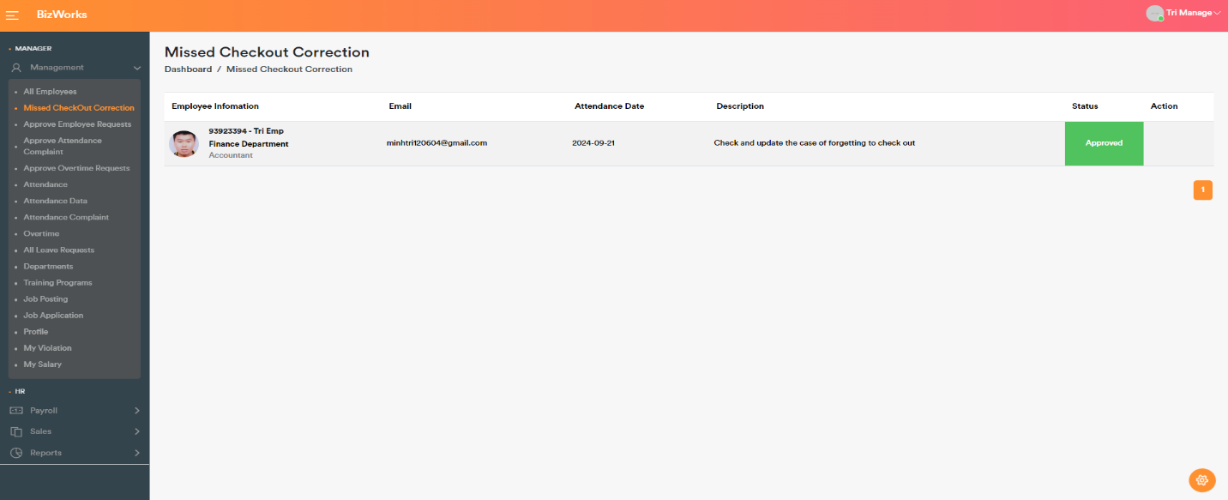

Approve Employee Requests

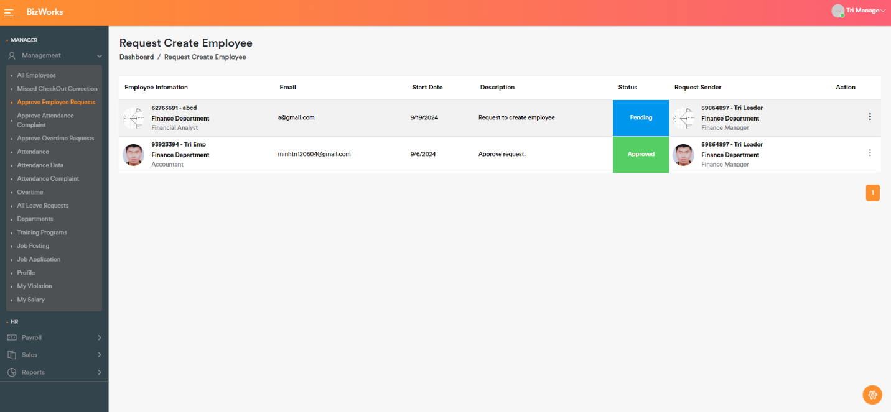

Daily Report

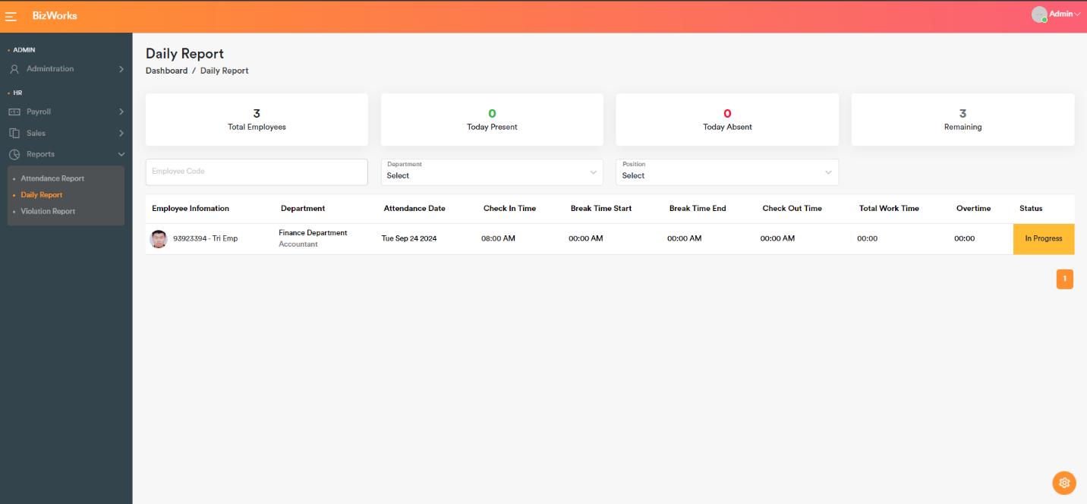

Job Application List

